File permissions in Linux

Project description
For this project I was given instructions by the organization to examine existing permissions to the files and directories and then determine if the permissions matched the authorizations permitted by the company. If they did not, I was required to make the necessary changes so that permissions matched the correct authorizations.

Check file and directory details
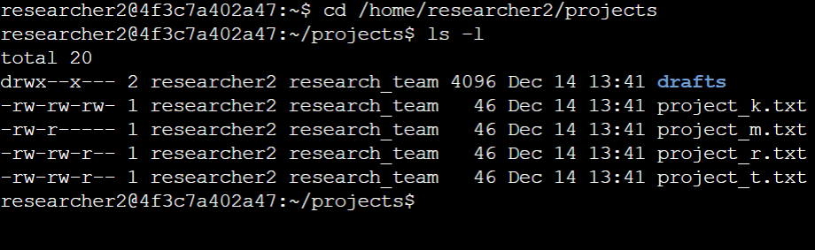
In order to check file and directory details in Linux, first you must change to the correct directory using the “cd” command. Above, I used “cd /home/researcher2/projects” to open the “projects” directory. Then, I used “ls -l” to display the permissions of each of the files and folders in the directory.

Describe the permissions string

The permissions string shows who has what permissions for each file or directory. For the project_r.txt file, it shows the following permissions string “-rw-rw-r--”. The first “-” shows that it is a file and not a directory. The following “rw-” in the string shows that the user has read and write permissions, but not execute permissions. Then, the next “rw-” in the string shows that the group has read and write permissions, but not execute permissions. The final three characters “r- -” means that other users only have read permissions, but not write or execute permissions.

Change file permissions
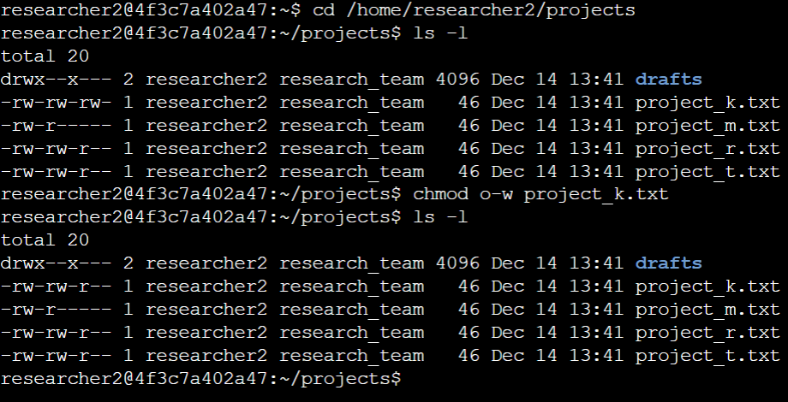
The organization does not allow any other to have write permissions on files. After showing the details of the file permissions using “ls -l” I can see that “project_k.txt” has write permissions enabled for “other.” To change this, I use the “chmod” command. I wrote “chmod o-w project_k.txt” . “o” represents “other”, “-” represents that I want to remove the permission, and “w” represents the permission “write” that I want to remove. Then, I write the file name that I want the permission change to apply to. Once I have done this, I will use the “ls -l” command again to ensure that the change has occurred correctly.

Change file permissions on a hidden file
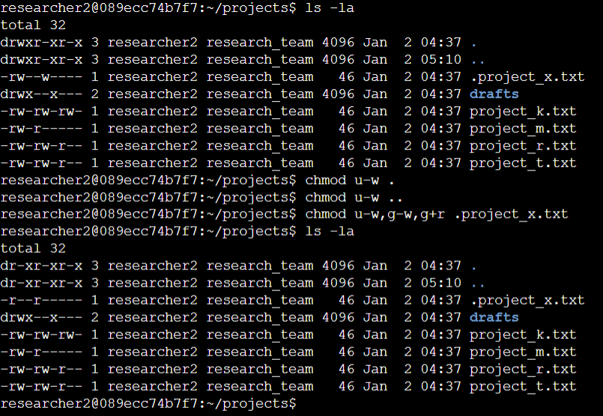
The organization does not want anyone to have “write” permissions on any of the hidden files, but wants the users and groups to have “read” permissions on them. To display the hidden file permissions, I use the command “ls -la” which will display any files in the directory, including hidden ones. We see several hidden files displayed with a “.” before the file names. We can see that there are three hidden files that need permission modifications. The hidden file “.” and “..” have write permissions for the user and the hidden file “.project_x.txt” has write permissions for both the user and the group, but the group does not have read permissions. First, I use the “chmod” command to remove the write permissions from the user for the “.” and “..” hidden files. I write “chmod u-w .” and “chmod u-w ..” to remove the write permissions. The “u” represents “user”, the “-” shows I want to remove permissions, and the “w” represents “write”. Then, I use the “chmod” command to remove the write permissions for the user and group for the “.project_x.txt” file by typing “chmod u-w,g-w,g+r .project_x.txt”. The “u” represents the user, the “g” represents the group, the “-” shows I want to remove a permission, and the “w” represents write permissions. The “g+r” shows I want to add the “read” permission to the “group”. Once I have made the changes needed, I write “ls -la” to show the new permission modifications to all of the files in the directory, including the hidden ones and see that the permissions now show that no hidden files have write permissions and the groups on hidden files have read permissions.

Change directory permissions
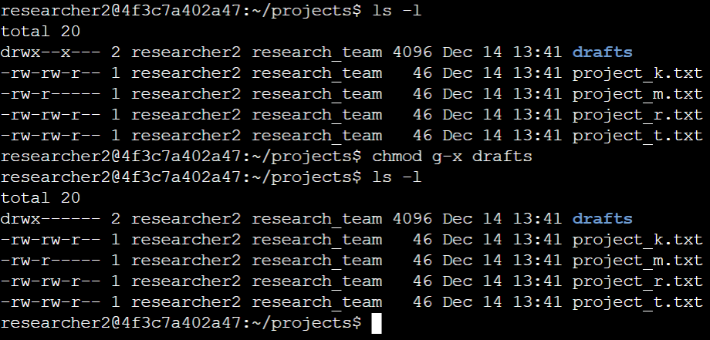
The organization wants only “researcher2” to have executive permissions to the drafts directory. First, I type “ls -l” to show the contents of the projects directory. I see that the drafts directory has the following permissions “drwx--x---”. The first “x” shows that the user has executive permissions, but the second “x” shows that the group also has executive permissions. In order to remove the permissions for the group, I type “chmod g-x drafts”. The “g” represents “group, the “-” shows I want to remove permissions, the “x” represents the executive permission, and “drafts” means that I want the changes to affect the “drafts” directory. After, I run the “ls -l” command again to ensure that the correct modifications were made. Now, only the user “researcher2” has executive functions for the drafts directory.

Summary
For this project I was able to access and visualize the permissions for the projects folder. I was given instructions as to what permissions should be given or taken away from different files and folders in the directory. I used the “ls -l” and “ls -la” commands to see the files, including hidden files, in the “projects” directory. I explained what the permissions string represents and how it can be read. I explained how to change file permissions for the user, group, and others. I explained how to change permissions for the different files, how to visualize hidden files and change permissions for them as well. I also showed how to change permissions for directories.

